**A000-Eur-Czech Rep-venus from Petřkovice, Silesia, CZ,**

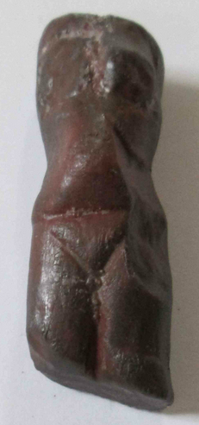 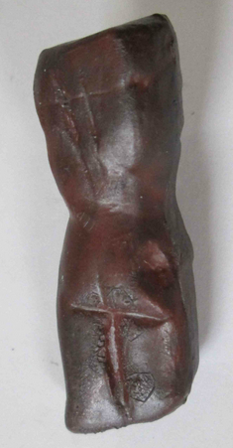

Case no. 1

**professional cast resin replica of venus from Petřkovice, Silesia, CZ, EU.**

**Size 45 x 15 x 13 mm.**

The **Venus of Petřkovice** ([Czech](http://en.wikipedia.org/wiki/Czech_language): *Petřkovická venuše* or *Landecká venuše*) is a [Venus figurine](http://en.wikipedia.org/wiki/Venus_figurines), a [mineral](http://en.wikipedia.org/wiki/Mineral) [statuette](http://en.wikipedia.org/wiki/Statue) of a nude female figure, dated to about 23,000 [BCE](http://en.wikipedia.org/wiki/Common_Era) ([Gravettian](http://en.wikipedia.org/wiki/Gravettian) [industry](http://en.wikipedia.org/wiki/Archaeological_industry)), which was found within the current city limits of [Ostrava](http://en.wikipedia.org/wiki/Ostrava) (Ostrava-Petřkovice), [Silesia](http://en.wikipedia.org/wiki/Silesia), the [Czech Republic](http://en.wikipedia.org/wiki/Czech_Republic). It is now in the Archeological Institute, [Brno](http://en.wikipedia.org/wiki/Brno).

It was found by archaeologist Bohuslav Klima on 14 July 1953. It was found beneath  a   m a m m o th molar at the ancient settlement of  m a m m o th hunters. Many stone artifacts and skeletal fragments were found nearby.

The statue measures 4.5 x 1.5 x 1.4 cm and is a headless torso of a body of a woman carved from iron ore ([hematite](http://en.wikipedia.org/wiki/Hematite)). Uniquely, the absence of the head appears to be the author's intention. Also, unlike other prehistoric Venus figurines, it shows a slender young woman or girl with small breast.[[2]](http://en.wikipedia.org/wiki/Venus_of_Pet%C5%99kovice#cite_note-2)

• Leslie G. Freeman (ed.), *Views of the Past: Essays in Old World Prehistory and Paleanthropology*, Mounton Publishers, 1978, [ISBN 90-279-7670-8](https://en.wikipedia.org/wiki/Special:BookSources/9027976708).

• [Ice Age Art: Arrival of the Modern Mind](http://www.britishmuseum.org/whats_on/exhibitions/ice_age_art.aspx?utm_source=Twitter&utm_medium=Biog&utm_campaign=Ice%2BAge%2BArt)